# Lightweight testing of heavyweight IBM Message Broker solutions

## Summary

This article shows a hands-on approach of how you can test your IBM WebSphere Message Broker solutions in a simple way using modern Groovy and Java tools.

The approach taken could actually be used with more or less any integration platform although some actually do have built-in ways of doing it, like Apache Camel.

## Introduction

Testing distributed enterprise integration using in our case IBM WebSphere MQ and IBM WebSphere Message Broker (IBM call it for their advanced ESB) is no so easily done as it ought to be.

The built in support for testing is not helping us much (see Test Client in resources).

At my current assignment there is a wealth of different approaches: JMeter, SoapUI, RFHUtil, MbTest, JUnit, end-to-end user testing, in-house developed testing tools.

I want a better approach that works well with our CI server and here is the start of that journey. To showcase I will use a vanilla IBM WebSphere Message Broker with default configuration (see appendix for links) and then one of the basic application samples for coordinated request/reply.

## Imagine all you had to write was…

where:

testFileName | expectedFileName | requestQ | replyQ | ignoreNamedElementsNames

'request1.xml' | 'reply1.xml' | 'GET_REQREP_IN' | 'GET_REQREP_OUT' | [ 'CompletionTime', ‘e2’]

'request2.xml' | 'reply2.xml' | 'GET_REQREP_IN' | 'GET_REQREP_OUT' | [ 'CompletionTime' ]

To “inject” the data into the test that will be run once per row above (omitting the details)

given: "A XML payload to send"

and: "An expected reply XML payload"

and: "Ignoring differences for configured element names"

when: "The request is sent"

then: "A reply is received"

and: "The reply payload contains similar XML"

The actual code looks like this:

Figure 1 - The code in the IDE

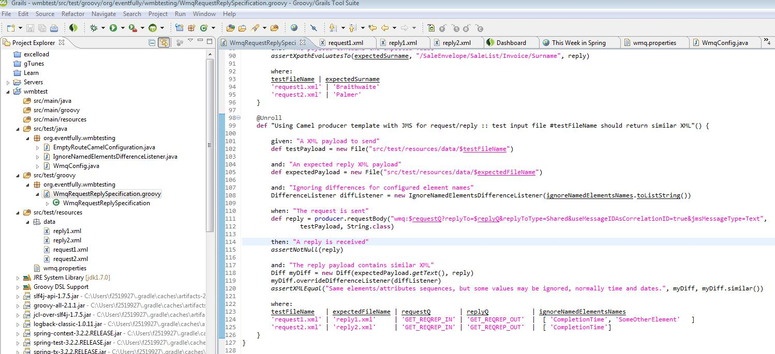

To configure it with your queuemanager, just edit a simple properties file (src/test/resources/wmq.properties)

qmgr.hostName=localhost

qmgr.port=2414

qmgr.queueManager=MB8QMGR

qmgr.channel=SYSTEM.AUTO.SVRCONN

#0 = binding, 1 = client, 8 = first binding, then client

qmgr.transportType=1

Then to test it:

# Use gradlew.bat or gradlew if you don't want to install Gradle

gradle test

Check the results graphically in "build/reports/tests/index.html"

Figure 2 - Spock test results

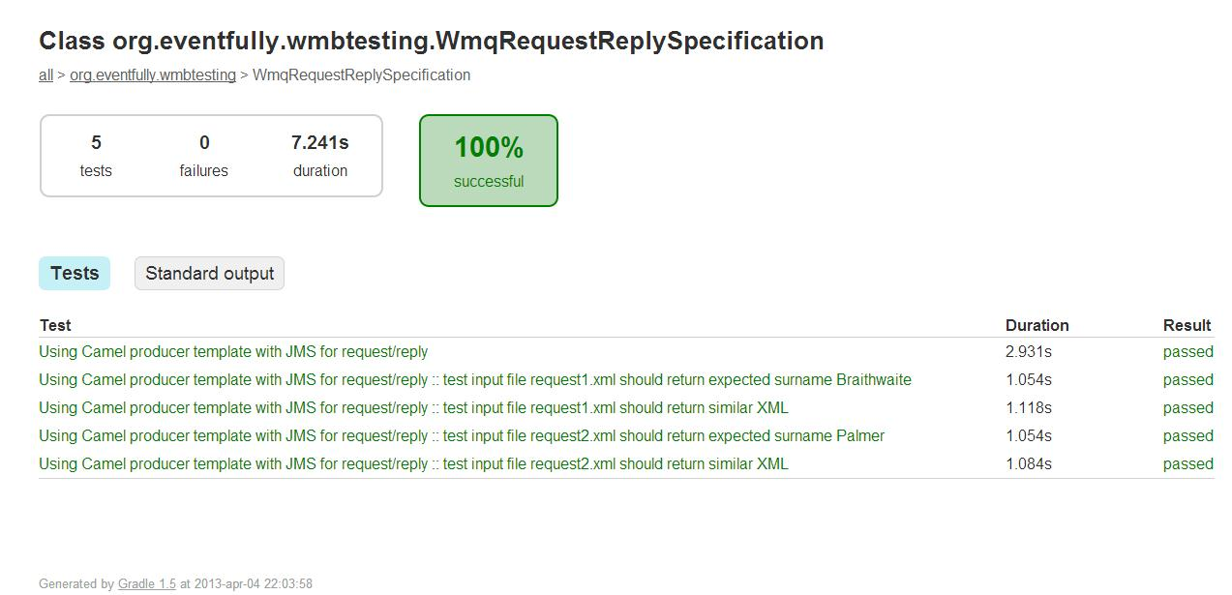

If you prefer, you can actually run it as a JUnit test directly from your IDE instead.

Figure 3 - JUnit result from "run as JUnit test" in GGTS

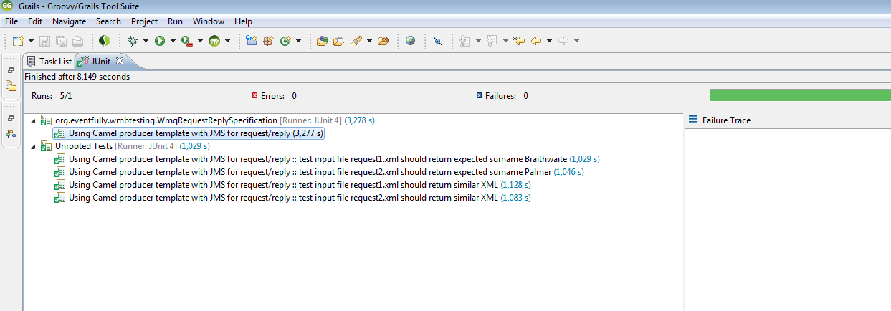

## Appendix A - Setting up the WMB samples

Summary with pictures:

Figure 4 - Start the WMBT with a new workspace and then start from samples

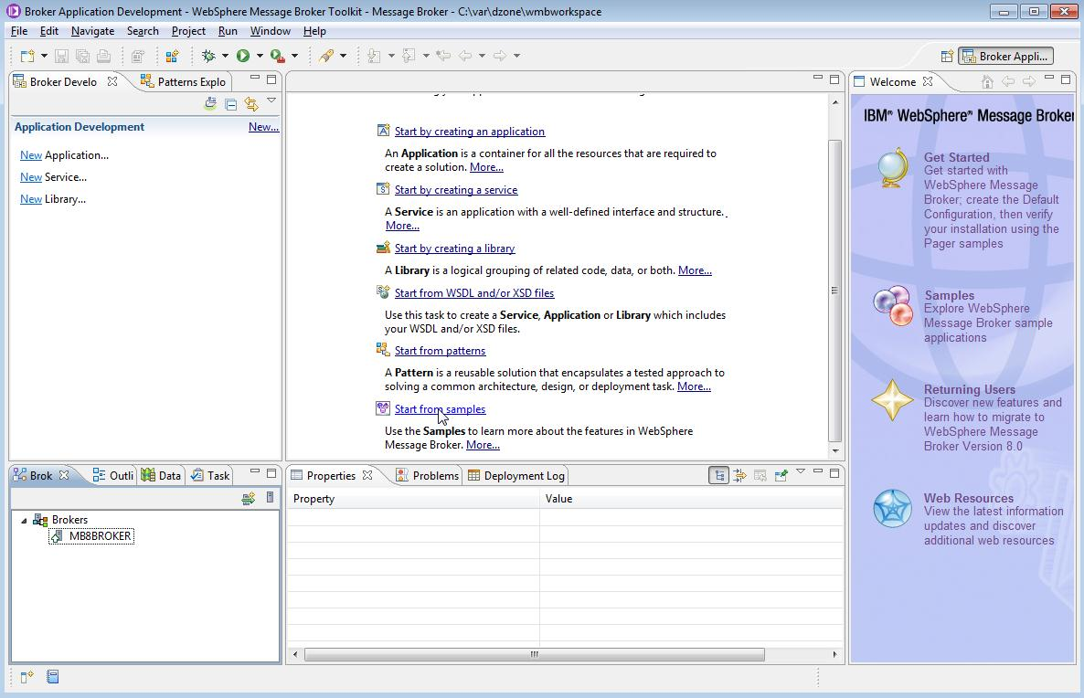

Figure 5 - Choose the "Coordinated Request Reply sample"

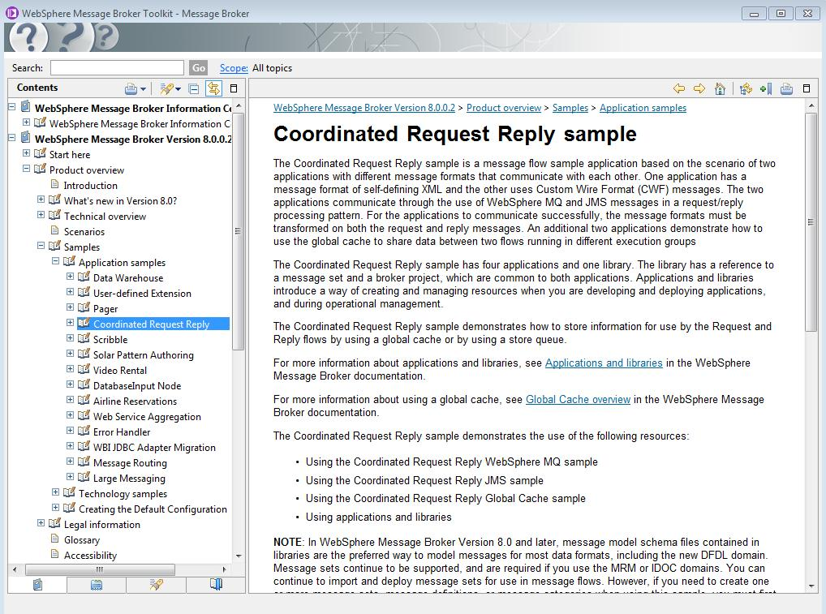

Figure 6 - Import and deploy the sample

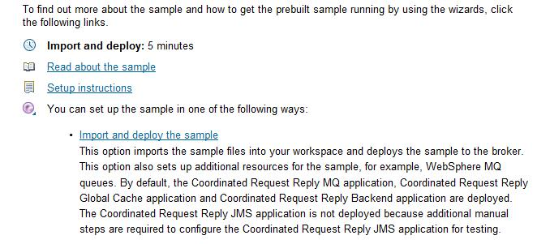

Figure 7 - Import summary that all went well

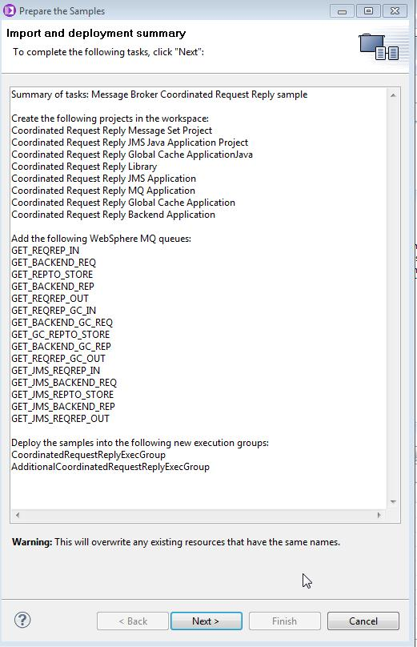

Figure 8 - Check that the applications are deployed to the Execution Groups

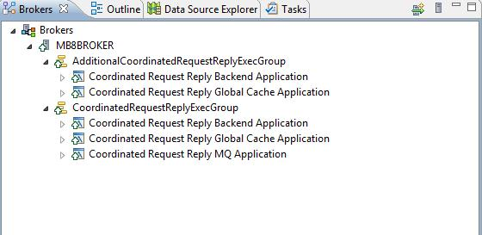

## Appendix B - Environment used

In case we run into the infamous “works on my machine” syndrome.

### IDE

Groovy/Grails Tool Suite – version: 3.2.0.RELEASE

### Build tool – Gradle

------------------------------------------------------------

Gradle 1.4

------------------------------------------------------------

Gradle build time: den 28 januari 2013 kl 3:42 UTC

Groovy: 1.8.6

Ant: Apache Ant(TM) version 1.8.4 compiled on May 22 2012

Ivy: 2.2.0

JVM: 1.7.0 (Oracle Corporation 21.0-b17)

OS: Windows 7 6.1 amd64

### IBM WebSphere MQ

Name: WebSphere MQ

Version: 7.0.1.8

CMVC level: p701-108-120224

### IBM WebSphere Message Broker

BIP8927I: Broker Name 'MB8BROKER'

Queue Manager = 'MB8QMGR'

Operation mode = 'advanced'

Fixpack capability level = 'all' (effective level '8.0.0.2')

### Operating System

OS Name: Microsoft Windows 7 Enterprise

OS Version: 6.1.7601 Service Pack 1 Build 7601

System Model: HP EliteBook 8540w

System Type: x64-based PC

## Appendix C - Additional resources and links

### The source code for this article at GitHub

Download, clone or fork from:

<https://github.com/magnuspalmer/wmbtesting>

### Spock framework

Spock is a testing and specification framework for Java and Groovy applications. Since it is JUnit under the hood, it works fine with many IDEs, build tools and CI servers.

<https://code.google.com/p/spock/>

### Gradle enterprise build automation

The build, test and deployment killer app, bye bye Maven....

<http://www.gradle.org/>

### Apache Camel

Lightweight integration framework powered by really nice DSL.

<http://camel.apache.org/>

### XMLUnit

Java JUnit extensions that I think is great for comparing two XML documents.

<http://xmlunit.sourceforge.net/>

### IBM WMB Test Client

The documentation at Info Center for V8 for the Test Client.

<http://publib.boulder.ibm.com/infocenter/wmbhelp/v8r0m0/topic/com.ibm.etools.mft.doc/af52104_.htm>

### IBM WMB Setup default configuration

The documentation at Info Center for V8 for the default configuration.

<http://publib.boulder.ibm.com/infocenter/wmbhelp/v8r0m0/topic/com.ibm.etools.mft.doc/ae20200_.htm>